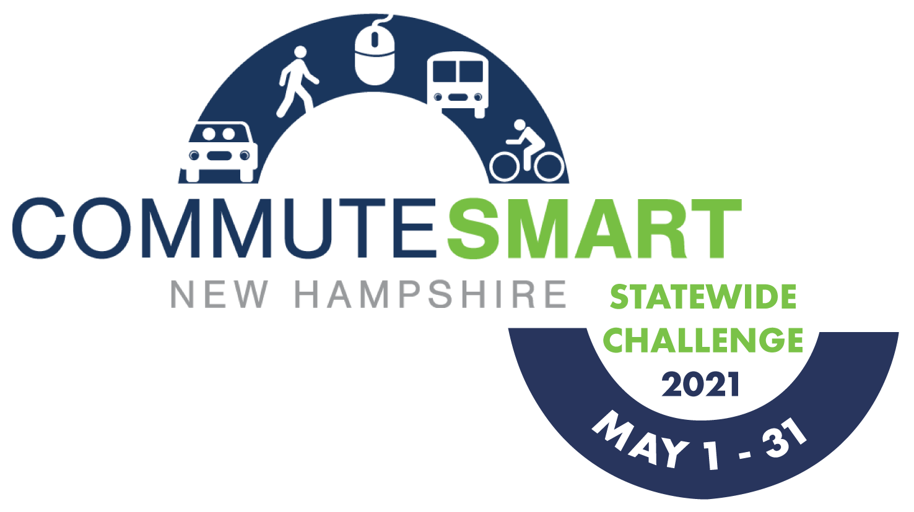
WEEKLY CHEERLEADING GUIDE
This guide is to provide Team Captain’s with pre-written, pre-dated, pre-thought out emails to encourage continuous team spirit throughout the challenge. Feel free to use these templates loosely and change language to fit your Team’s needs.

EMAIL BLAST #1
Suggested Send Date: April 1, 2021
Suggested Tagline: “Register for the CommuteSmart NH Challenge, May 1 – 31!”
During the month of May our workplace is competing in the CommuteSmart NH Statewide Commuter Challenge and I’m (we’re) the team captain(s). It’s a fun contest to use sustainable transportation and compete against other teams around the state!
All you have to do is commute to work using any mode other than driving alone. As many of us are working at home due to COVID-19, we can log these “trips” without even changing our daily routine! Other modes that count include bicycling, walking, skateboarding, taking transit, or any combination of these.
Log in or sign up on the trip logger to join our company team (our team name is _______) and be ready to start logging your trips beginning May 1. Trips are logged for your commute to and from work and do not count lunch or other non-work related trips.

EMAIL BLAST #2
Suggested Send Date: April 26, 2021
Suggested Tagline: “Don’t Forget to Register for the CommuteSmart NH Challenge, May 1 – 31!”
The CommuteSmart NH Statewide Challenge starts this Saturday! Be sure that you’re registered on the trip logger and signed up for the [Company Name] Team! CommuteSmart NH will be awarding employers at the end of the month that logged the most sustainable trips (on a per capita level). So the more trips we log the better chances we have at winning the title of Most Sustainable Trips!
If you’ve already joined our team, thanks so much! We’ve got this!

EMAIL BLAST #3
Suggested Send Date: Monday,May 3, 2021
Suggested Tagline: “The CommuteSmart NH Statewide Challenge has started!!”
The CommuteSmart NH Statewide Challenge has started! If you haven’t joined our company team yet, please do so by logging in or signing up. If you have already joined, thank you!
Telecommuting trips are being counted as part of this challenge! As the challenge progresses, if you would like to see how our team stands against other teams, as well as where you rank within our own team, you can view the leaderboard online where you log your trips. Remember, the more days you commute smart, the better chance we have of being statewide champions!

EMAIL BLAST #4
Suggested Send Date: May 14, 2021
Suggested Tagline: “Let’s do this!”
We’re almost halfway through the Challenge! Are you getting into the habit of logging your trips? Most folks do it as they start their work day in the morning or during lunch. Login and check out the leaderboard to see where we stand!
Don’t forget we could win the award for “Most Social Media Buzz!” Just post on Facebook or Twitter with #SmartCommuteTheRoute and our company name.
Keep up the good work everyone!!!

EMAIL BLAST #5
Suggested Send Date: May 24, 2020
Suggested Tagline: Don’t forget to log your trips!
Just a friendly reminder to take a moment to make sure all of your trips are logged! It’s a numbers game, the more trips we log, the better our chances for winning. This is also the last full week of the challenge, so let’s make these last few days count!
Go team!
Log your trips here!

EMAIL BLAST #6
Send Date: May 28, 2021
Tagline: The Challenge ends on Monday!
The Challenge ends this coming Monday, May 31th! Don’t forget to log your trips! If you didn’t log, it didn’t happen! All trips must be logged by Sunday, June 6th at 11:59 PM!
Log your trips here!

EMAIL BLAST #7
Send Date: Monday, June 7, 2021
Tagline: “Thank you for commuting smart!”
Thanks to everyone on our team for your effort in the CommuteSmart NH Statewide Challenge!
Please take a moment to complete this very short, and anonymous survey to give CommuteSmart NH important feedback to make the Challenge even better next year.
Just because the Challenge is over, that doesn’t mean that you should stop commuting sustainably! You can also be on the lookout for future commuter challenges held throughout the year.
Again, thanks so much for commuting smart!

