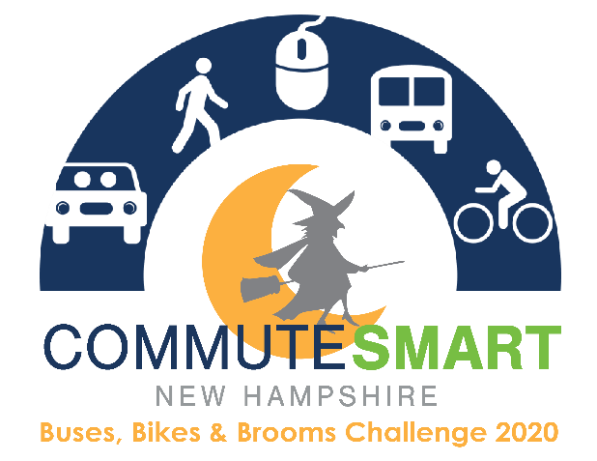

Weekly Cheerleading Guide

This guide is to provide Team Captain’s with pre-written, pre-dated, pre-throughout out emails to encourage continuous team spirit throughout the challenge. Feel free to use these templates loosely and change language to fit your Team’s needs.

Email Blast #1
Suggested Send Date: September 21, 2020
Suggested Tagline: “Register for the Buses, Bikes, & Brooms Commuter Challenge!”

During the month of October our workplace is competing in the CommuteSmart NH Buses, Bikes, & Brooms Commuter Challenge and I’m (we’re) the team captain(s). It’s a fun contest to use sustainable transportation and compete against other teams around the state!

All you have to do is commute to work using any mode other than driving alone. As many of us are working at home due to COVID-19, we can log these “trips” without even changing our daily routine! Other modes that count include bicycling, walking, skateboarding, taking transit, or any combination of these.

Log in or sign up on the new trip logger to join our company team (our team name is _______) and be ready to start logging your trips beginning October 1. Trips are logged for your commute to and from work and do not count lunch or other non-work related trips.

Email Blast #2
Suggested Send Date: September 28, 2020
Suggested Tagline: “Don’t forget to register for the Buses, Bikes & Brooms Challenge, October 1-31!”

The Buses, Bikes & Brooms Challenge starts this Thursday! Be sure that you’re registered on https://trips.commutesmartnh.org/login and signed up for the [Company Name] Team! CommuteSmart NH will be awarding employers at the end of the month that logged the most sustainable trips (on a per capita level) as well as raffling off individual prizes weekly throughout the month. So the more trips we log the better chances we have at winning the title of Most Sustainable Trips!

Email Blast #3
Suggested Send Date: October 1, 2020
Suggested Tagline: “The Buses, Bikes & Brooms Challenge has started!”

The Buses, Bikes, & Brooms Challenge has started! If you haven’t joined our company team yet, please do so by logging in or signing up at https://trips.commutesmartnh.org/login. If you have already joined, thank you!

Telecommuting trips are being counted as part of this challenge! As the challenge progresses, if you would like to see how our team stands against other teams, as well as where you rank within our own team, you can view the leaderboard online where you log your trips. Remember, the more days you commute smart, the higher the chance you have in winning a raffle prize!

Email Blast #4
Suggested Send Date: October 12, 2020
Suggested Tagline: “Let’s do this!”

Were almost half way through the Challenge! Keep logging your trips! If you haven’t logged any yet, it’s not too late to start. We still have a few weeks left to either try a sustainable option or to log any smart commute trips you’ve taken since October 1.

Feel free to share your smart commute trips on social media using #BusesBikeandBrooms and [company name]. An award for Most Social Media Buzz will be given out at the end of the Challenge to the team with the most social media interaction!

Email Blast #5
Suggested Send Date: October 19, 2020
Suggested Tagline: “Don’t forget to log your trips!”

Have you been remembering to log your trips? The more days that you log, the more chances you have to win a raffle prize! If you’re curious about how our team is measuring up you can login to review our team stats and see where we stand in the leaderboard.

If you haven’t had a chance to participate yet, that’s okay too. You still have some time before the challenge ends, and every trip counts!

Email Blast #6
Suggested Send Date: October 26, 2020
Suggested Tagline: “The Challenge ends this week!”

The challenge ends this Saturday! Let’s finish the challenge strong and try to get those last few trip logged. If you didn’t log it, it didn’t happen! All trips must be logged by Wednesday, November 4th at 11:59 PM!

Email Blast #7
Suggested Send Date: November 2, 2020
Suggested Tagline: “Thank you for Commuting Smart!”

Thanks to everyone on our team for your effort in the Buses, Bikes & Brooms Challenge! You have through Wednesday, November 4th to log your trips.

Please take a moment to complete this very short, and anonymous survey to give CommuteSmart NH important feedback to make the Challenge even better next year.
Just because the Challenge is over, that doesn’t mean that you should stop commuting sustainably! You can also be on the lookout for future commuter challenges held throughout the year.
Again, thanks so much for commuting smart!

