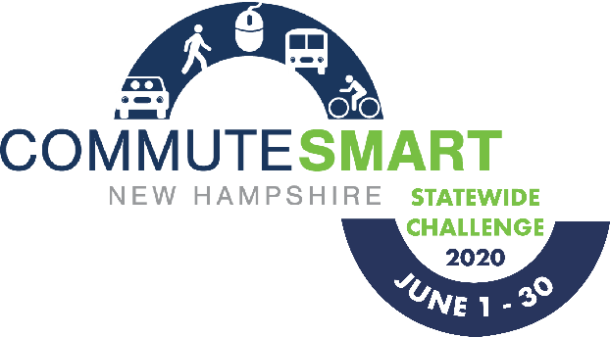
WEEKLY CHEERLEADING GUIDE
This guide is to provide Team Captain’s with pre-written, pre-dated, pre-thought out emails to encourage continuous team spirit throughout the challenge. Feel free to use these templates loosely and change language to fit your Team’s needs.

EMAIL BLAST #1
Suggested Send Date: May 4, 2020
Suggested Tagline: “Register for the CommuteSmart NH Challenge, June 1 – 30!”
Have you heard?! Our company is competing in the upcoming CommuteSmart NH Statewide Challenge and I’m (we’re) the team captain(s). It’s a fun contest to use sustainable transportation during the month of June.
All you have to do is commute to work using any mode other than driving alone (e.g. carpooling, riding your bike or skateboard, walking, transit, working from home, or any combination of these). If you work a compressed work week, then your day off also counts!
Start by registering online and then easily log your trips throughout the month of June. You don’t have to commute smart every single day in order to participate; this program can easily fit into your daily schedule! As a team we will be able to compete with others across the state and monitor our progress on real-time leaderboards. Not to mention we will be saving money otherwise spent on gas, tolls, and car maintenance all while helping the environment. In addition to competing as a team, CommuteSmart NH will be giving out other fun prizes throughout the month!
Register online here!

EMAIL BLAST #2
Suggested Send Date: May 25, 2020
Suggested Tagline: “Don’t Forget to Register for the CommuteSmart NH Challenge, June 1 – 30!”
In case you haven’t heard yet, our company is competing in the upcoming CommuteSmart NH Statewide Challenge and I’m (we’re) the team captain(s). There’s only one week left before the challenge begins! It kicks off June 1, and runs through June 30.

Click here to join our team and be part of the smartest, greenest workforce by carpooling, vanpooling, riding your bicycle or skateboard, walking, taking transit, or teleworking!

Three winning teams will be awarded challenge trophies for most sustainable trips (one for each of three employer size categories) and one winning team will win the award for most social media buzz.

If you’ve already joined our team, thanks so much! We’ve got this!

EMAIL BLAST #3
Suggested Send Date: Monday, June 1, 2020
Suggested Tagline: “The Challenge has started!!”
Today is the first day of the CommuteSmart NH Statewide Challenge! Thank you all for joining our team! First and most importantly, log your trips on NH Rideshare. As the Challenge progresses, you will see how our team ranks against other teams.
In addition to logging trips, we encourage you to post on Facebook and Twitter using #SmartCommuteTheRoute and our [company name]. We could win the award for “Most Social Media Buzz!”
Also, CommuteSmart NH will be giving out fun prizes throughout the challenge so it’s important to log your trips!
Let the games begin!

EMAIL BLAST #4
Suggested Send Date: June 8, 2020
Suggested Tagline: “Let’s do this!”
Are you getting into the habit of logging your trips? Most folks do it as they start their work day in the morning or during lunch. Login and check out the leaderboard to see our stats on how much money we are saving and carbon emissions we are reducing!
Don’t forget we could win the award for “Most Social Media Buzz!” Just post on Facebook or Twitter with #SmartCommuteTheRoute and our company name.
Keep up the good work everyone!!!

EMAIL BLAST #5
Suggested Send Date: June 22, 2020
Suggested Tagline: Don’t forget to log your trips!
Just a friendly reminder to take a moment to make sure all of your trips are logged! It’s a numbers game, the more trips we log, the better our chances for winning. This is also the last full week of the challenge, so let’s make these last few days count!
Go team!

EMAIL BLAST #6
Send Date: June 29, 2020
Tagline: The Challenge ends tomorrow!
The Challenge ends tomorrow, June 30th! Don’t forget to log your trips in NH Rideshare. If you didn’t log, it didn’t happen! All trips must be logged by this Sunday, July 5th at 11:59 PM!

EMAIL BLAST #7
Send Date: Thursday, July 2, 2020
Tagline: “A HUGE thanks for commuting smart!”
Thanks to everyone on our team for your fantastic effort in the CommuteSmart NH Statewide Challenge! You have until Sunday, July 5, at 11:59 PM to log your trips for the month! Winning teams will be announced next week so be on the lookout!
Please take a moment to complete this very short, and anonymous survey to give CommuteSmart NH important feedback to make the Challenge even better next year.
Survey link: https://forms.gle/9wPxvfuMgQzGz4jt8
Just because the Challenge is over, that doesn’t mean that you should stop commuting sustainably. You may continue using our trip logger throughout the year to track your savings and emissions reductions.
Again, thanks so much for commuting smart!

