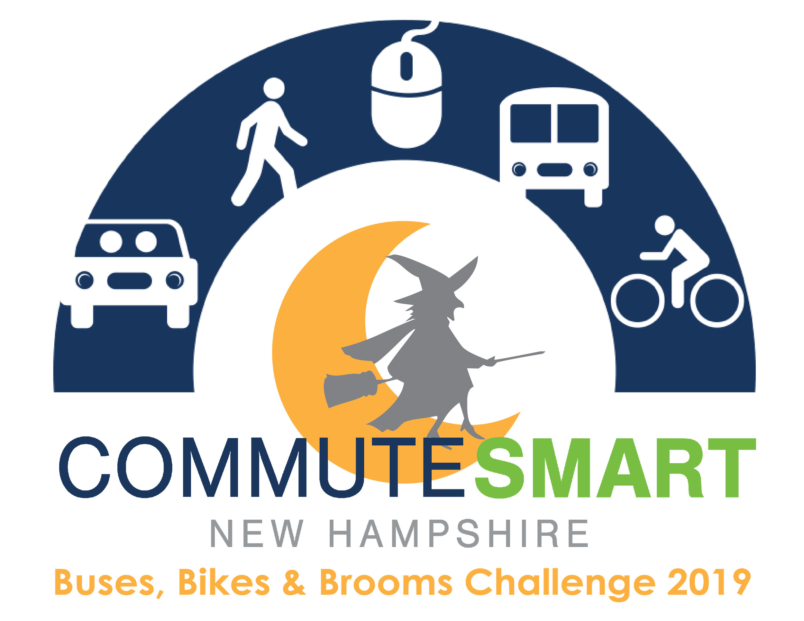

Weekly Cheerleading Guide

This guide is to provide Team Captain’s with pre-written, pre-dated, pre-throughout out emails to encourage continuous team spirit throughout the challenge. Feel free to use these templates loosely and change language to fit your Team’s needs.

Email Blast #1
Suggested Send Date: October 13, 2019
Suggested Tagline: “Register for the Buses, Bikes, & Brooms Commuter Challenge!”

At the end of the month our workplace is competing in the upcoming CommuteSmart NH Buses, Bikes, & Brooms Commuter Challenge and I’m (we’re) the team captain(s). It’s a fun contest to use sustainable transportation for the two weeks between October 20 and November 2.

All you have to do is commute to work using any mode other than driving alone (e.g. carpooling bicycling/skateboarding, walking, public transit, working from home, or any combination of these). Log in or sign up on NH Rideshare to join our team (our team name is _______) and be ready to start logging your trips beginning October 20.

Email Blast #2
Suggested Send Date: October 20, 2019
Suggested Tagline: “The Buses, Bikes & Brooms Challenge has started!”

The Buses, Bikes, & Brooms Challenge has started! If you haven’t joined our team yet, please do so by logging in or signing up at NH Rideshare. If you have already joined, thank you!

All trips will be logged in NH Rideshare using the Commute Log. Prizes will be given out on an individual basis depending on the number of days you commute smart during the challenge. As the challenge progresses, if you would like to see how our team stands against other teams, as well as where you rank within our own team, you can view the leaderboard in the NH Rideshare program. Remember, the more days you commute smart, the more prizes you can win!

Email Blast #3
Suggested Send Date: October 27, 2019
Suggested Tagline: “Don’t forget to log your trips! The Challenge is halfway over!”

Have you been remembering to log your trips? The more days that you log, the more prizes you can win. If you’re curious about how our team is measuring up you can login to review our team stats and see where we stand!

If you haven’t had a chance to participate yet, that’s okay too. You still have a few days before the challenge ends, and every trip counts!

Email Blast #4
Suggested Send Date: November 3, 2019
Suggested Tagline: “Thank you for Commuting Smart!”

Thanks to everyone on our team for your effort in the Buses, Bikes & Brooms Challenge! You have through Wednesday, November 6th to log your trips.

Please take a moment to complete this very short, and anonymous survey to give CommuteSmart NH important feedback to make the Challenge even better next year.
Just because the Challenge is over, that doesn’t mean that you should stop commuting sustainably. You may continue using our trip logger throughout the year to track your savings and emissions reductions.
Again, thanks so much for commuting smart!

